***Session 2: HDFS***

***Assignment 2.2***

1. I have created a file in local max-temp.txt

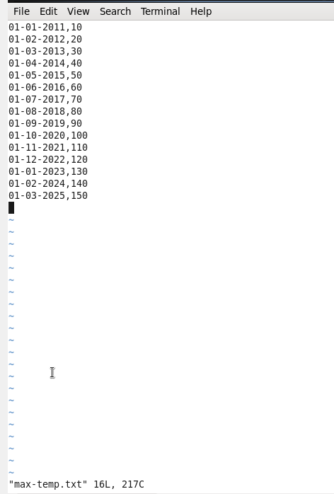

1. Moved the file to HDFS /user/acadgild/Hadoop/

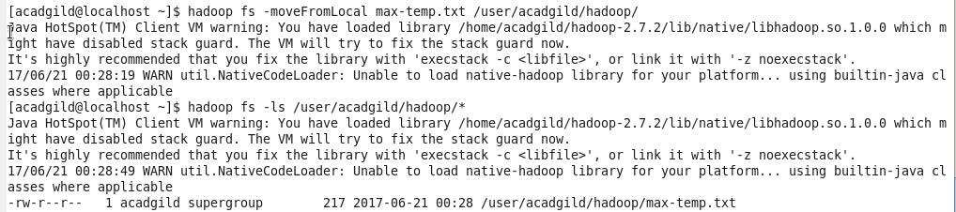

1. I have changed the permissions (774) in such a way that only owner and group members have full control on it

